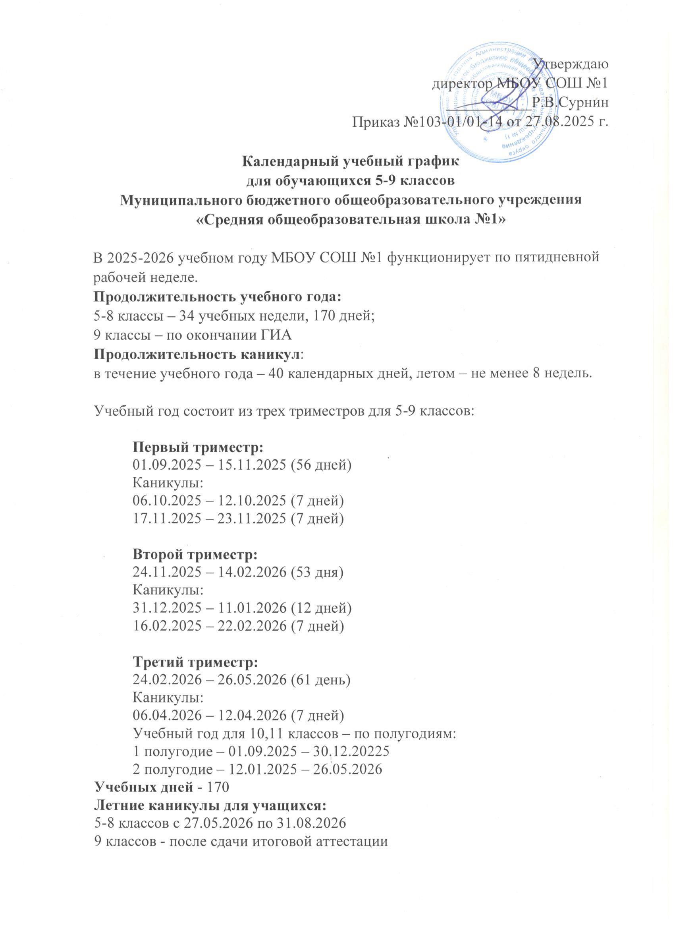

**Календарный учебный график на *2025/2026*  учебный год (5-9 кл.)**

| *Учебных дней* | **22** | | | | | | | **24** | | | | | | | | | | **15** | | | | | **22** | | | | | **15** | | | | | | **15** | | | | |
| --- | --- | --- | --- | --- | --- | --- | --- | --- | --- | --- | --- | --- | --- | --- | --- | --- | --- | --- | --- | --- | --- | --- | --- | --- | --- | --- | --- | --- | --- | --- | --- | --- | --- | --- | --- | --- | --- | --- |
| Месяцы | **Сентябрь** | | | | | | | **Октябрь** | | | | | | | | | | **Ноябрь** | | | | | **Декабрь** | | | | | **Январь** | | | | | | **Февраль** | | | | |
| *Дни недели* |  | |  | |  |  |  |  |  | |  | |  | |  | |  |  |  |  |  |  |  |  |  |  |  |  |  |  |  |  |  |  |  |  |  |  |
| Понедельник | **1** | | 8 | | 15 | 22 | 29 |  | 6 | | 10 | | 13 | | 20 | | 27 |  | **3** | 10 | 17 | 24 | 1 | 8 | 15 | 22 | 29 |  | **5** | 12 | 19 | 26 |  |  | 2 | 9 | 16 | **23** |
| Вторник | 2 | | 9 | | 16 | 23 | 30 |  | 7 | | 11 | | 14 | | 21 | | 28 |  | **4** | 11 | 18 | 25 | 2 | 9 | 16 | 23 | 30 |  | **6** | 13 | 20 | 27 |  |  | 3 | 10 | 17 | 24 |
| Среда | 3 | | 10 | | 17 | 24 |  | 1 | 8 | | 12 | | 15 | | 22 | | 29 |  | 5 | 12 | 19 | 26 | 3 | 10 | 17 | 24 | **31** |  | **7** | 14 | 21 | 28 |  |  | 4 | 11 | 18 | 25 |
| Четверг | 4 | | 11 | | 18 | 25 |  | 2 | 9 | | 13 | | 16 | | 23 | | 30 |  | 6 | 13 | 20 | 27 | 4 | 11 | 18 | 25 |  | **1** | **8** | 15 | 22 | 29 |  |  | 5 | 12 | 19 | 26 |
| Пятница | 5 | | 12 | | 19 | 26 |  | 3 | 10 | | 14 | | 17 | | 24 | | 31 |  | 7 | 14 | 21 | 28 | 5 | 12 | 19 | 26 |  | **2** | **9** | 16 | 23 | 30 |  |  | 6 | 13 | 20 | 27 |
| **Суббота** | 6 | | 13 | | 20 | 27 |  | 4 | 11 | | 15 | | 18 | | 25 | |  | 1 | 8 | 15 | 22 | 29 | 6 | 13 | 20 | 27 |  | **3** | **10** | 17 | 24 | 31 |  |  | 7 | 14 | 21 | 28 |
| **Воскресенье** | 7 | | 14 | | 21 | 28 |  | 5 | 12 | | 16 | | 19 | | 26 | |  | 2 | 9 | 16 | 23 | 30 | 7 | 14 | 21 | 28 |  | **4** | **11** | 18 | 25 |  |  | 1 | 8 | 15 | 22 |  |
| *Учебных дней* | **22** | | | | | | | **18** | | | | | | | | | | **17** | | | | |  | | | | |  | | | | | |  | | | | |
| **Месяцы** | **Март** | | | | | | | **Апрель** | | | | | | | | | | **Май** | | | | | **Июнь** | | | | | **Июль** | | | | | | **Август** | | | | |
| *Дни недели* |  |  | |  | |  |  |  | |  | |  | |  | |  | |  |  |  |  |  |  |  |  |  |  |  |  |  |  |  |  |  |  |  |  |  |
| Понедельник |  | 2 | | **9** | | 16 | 23/30 |  | | 6 | | 13 | | 20 | | 27 | |  | 4 | 11 | 18 | 25 | 1 | 8 | 15 | 22 | 29 |  | 6 | 13 | 20 | 27 |  |  | 3 | 10 | 17 | 24/31 |
| Вторник |  | 3 | | 10 | | 17 | 24/31 |  | | 7 | | 14 | | 21 | | 28 | |  | 5 | 12 | 19 | 26 | 2 | 9 | 16 | 23 | 30 |  | 7 | 14 | 21 | 28 |  |  | 4 | 11 | 18 | 25 |
| Среда |  | 4 | | 11 | | 18 | 25 | 1 | | 8 | | 15 | | 22 | | 29 | |  | 6 | 13 | 20 | 27 | 3 | 10 | 17 | 24 |  | 1 | 8 | 15 | 22 | 29 |  |  | 5 | 12 | 19 | 26 |
| Четверг |  | 5 | | 12 | | 19 | 26 | 2 | | 9 | | 16 | | 23 | | 30 | |  | 7 | 14 | 21 | 28 | 4 | **11** | 18 | 25 |  | 2 | 9 | 16 | 23 | 30 |  |  | 6 | 13 | 20 | **27** |
| Пятница |  | 6 | | 13 | | 20 | 27 | 3 | | 10 | | 17 | | 24 | |  | | **1** | 8 | 15 | 22 | 29 | 5 | 12 | 19 | 26 |  | 3 | 10 | 17 | 24 | 31 |  |  | 7 | 14 | 21 | 28 |
| **Суббота** |  | 7 | | 14 | | 21 | 28 | 4 | | 11 | | 18 | | 25 | |  | | **2** | **9** | 16 | 23 | 30 | 6 | 13 | 20 | 27 |  | 4 | 11 | 18 | 25 |  |  | 1 | 8 | 15 | 22 | 29 |
| **Воскресенье** | 1 | **8** | | 15 | | 22 | 29 | 5 | | 12 | | 19 | | 26 | |  | | **3** | 10 | 17 | 24 | 31 | 7 | 14 | 21 | 28 |  | 5 | 12 | 19 | 26 |  |  | 2 | 9 | 16 | 23 | 30 |